General Lab Info

Lab Website: http://www.psychiatry.wisc.edu/abercrombie/
Mailroom code: 3-6-9-8-7
Telephone info:
Lab Phone Number: (608)263-6114
Voicemail: 5-5500; pass code: 1419
To call on campus/within the building, dial last 5 digits of phone number (i.e., 3-6114)
Dial 9 to call outside campus locally.
Dial 8 to call long distance.
How to Connect to the Network (J: drive)
- Open ‘My Computer’
- Go to ‘Tools’ → ‘Map Network Drive…’
- Select ‘J:’ as your drive and ‘\\psych1\data’ as your folder

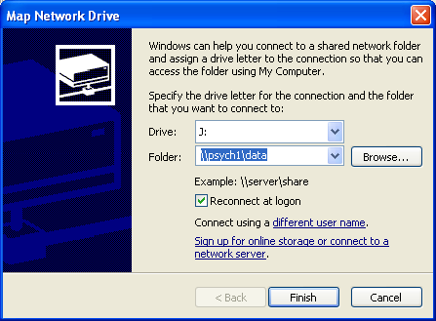

- Click on ‘Finish’
- Enter your WISPIC ‘Username’ and ‘Password’
- You’re now connected to the J: drive! ☺
How to Add a Printer:
- Go to Start → Control Panel → Printers and Other Hardware → Add a Printer
- ‘Add Printer Wizard’ will pop up. Click on ‘Next.’
- Choose ‘A network printer, or a printer attached to another computer.’ Click on ‘Next.’
- Choose ‘Browse for a printer.’ Click on ‘Next.’
- Wizard will locate all shared printers.
- You should select: WISPIC → PSYCHPRINT → rm1419color. Click on ‘Next.’
- Choose ‘Yes’ when asked if you want it to be the default printer. Click on ‘Next.’
- The printer in room 1419 is added! ☺

